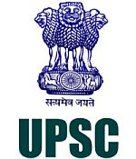

**UPSC Civil Services Exam - 2018**



**Downloaded From : www.iasexamcentre.com**

[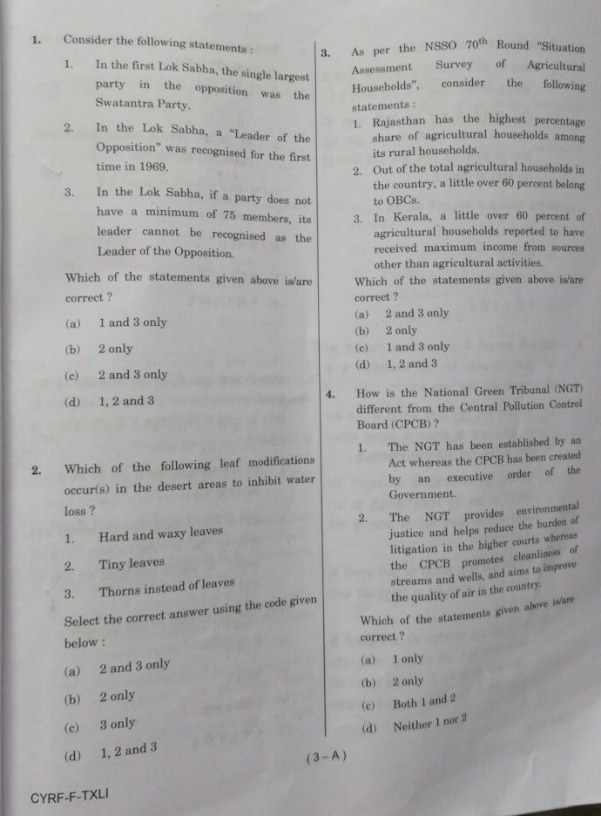](http://www.insightsonindia.com/wp-content/uploads/2018/06/image-1.jpg)

[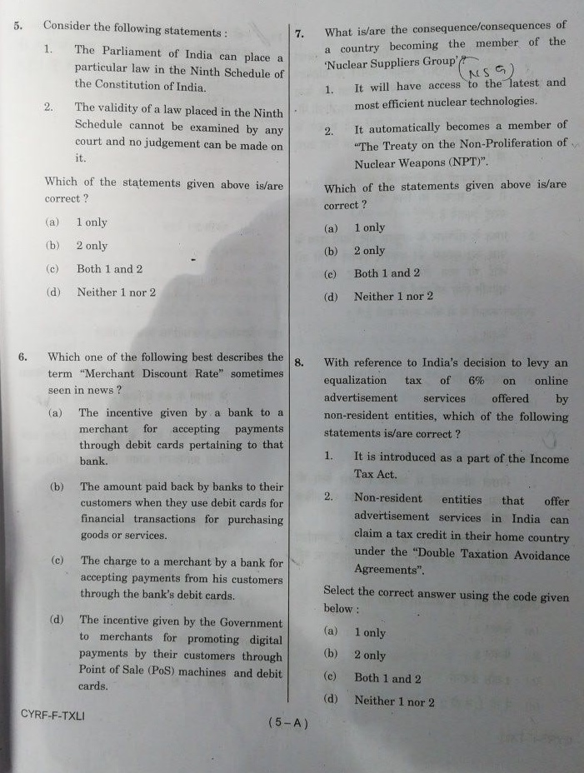](http://www.insightsonindia.com/wp-content/uploads/2018/06/image.jpg)[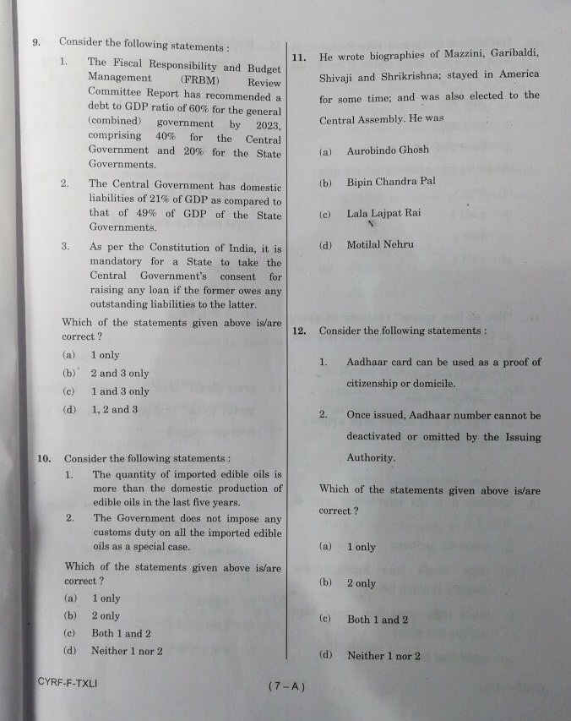](http://www.insightsonindia.com/wp-content/uploads/2018/06/IMG-5624.jpg)

[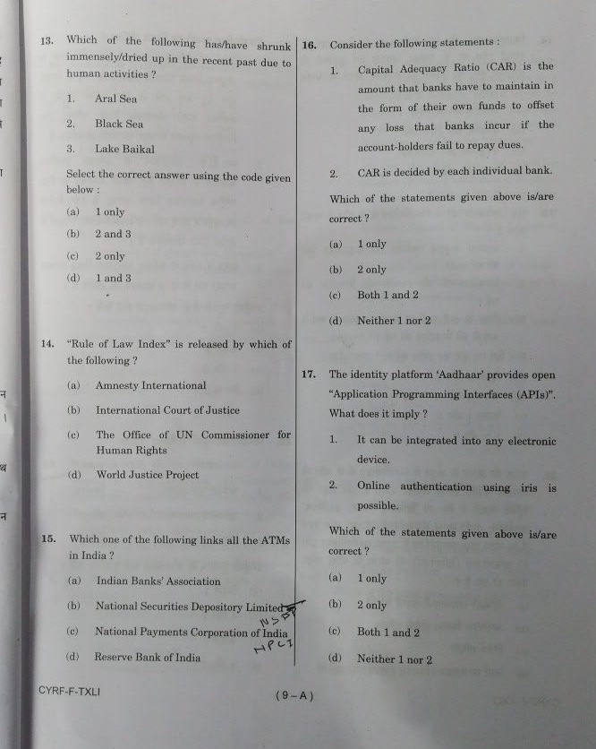](http://www.insightsonindia.com/wp-content/uploads/2018/06/IMG-5625.jpg)

[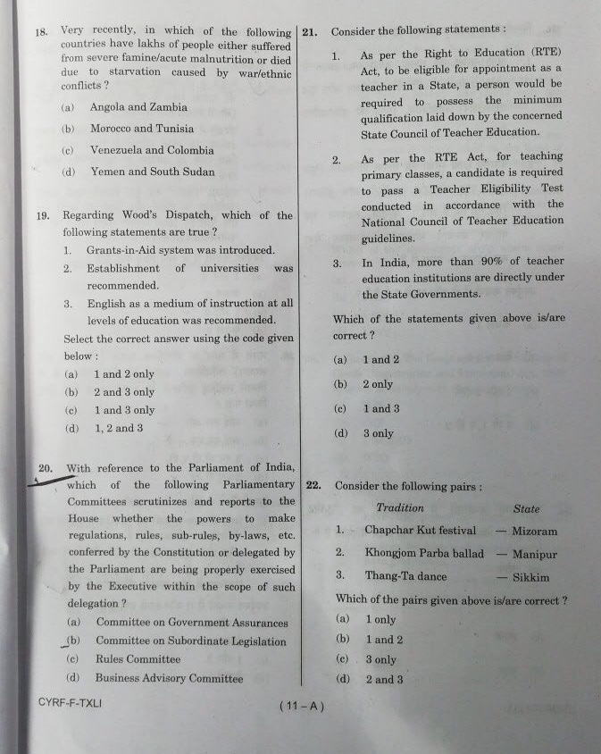](http://www.insightsonindia.com/wp-content/uploads/2018/06/IMG-5626.jpg)

[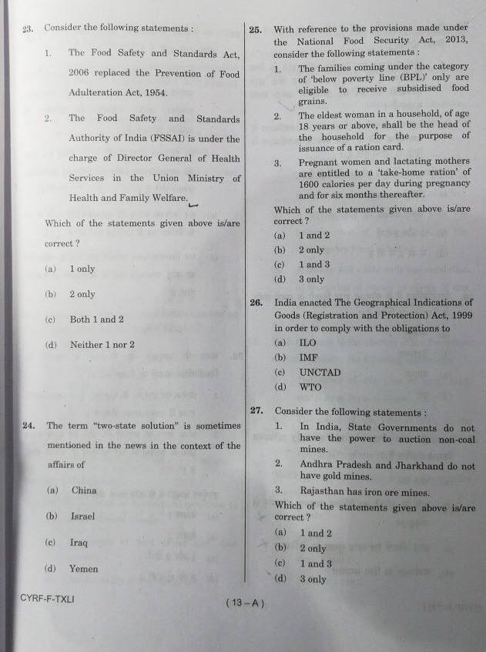](http://www.insightsonindia.com/wp-content/uploads/2018/06/IMG-5627.jpg)

[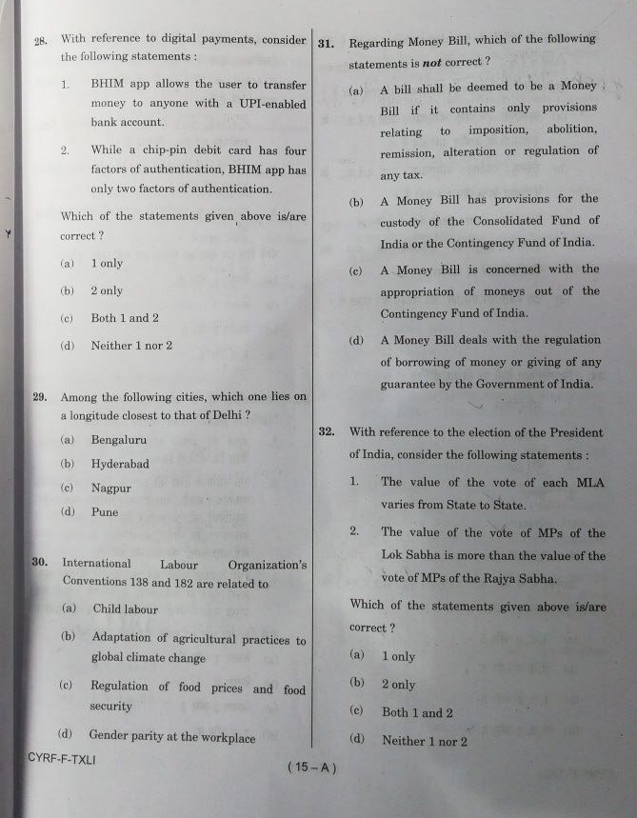](http://www.insightsonindia.com/wp-content/uploads/2018/06/IMG-5628.jpg)

[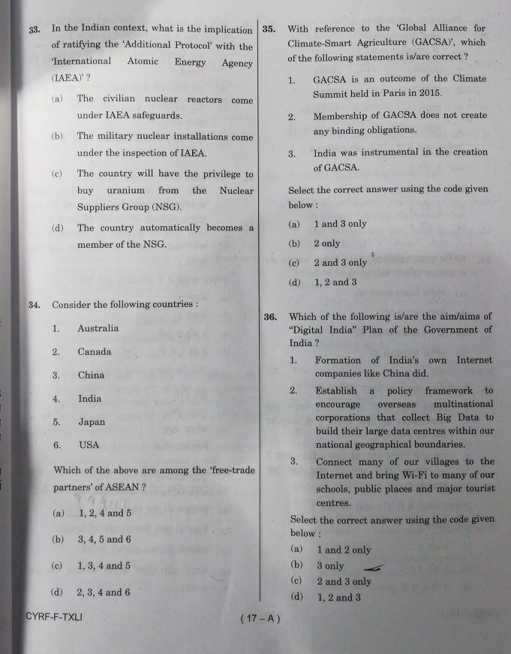](http://www.insightsonindia.com/wp-content/uploads/2018/06/IMG-5629-3.jpg)

[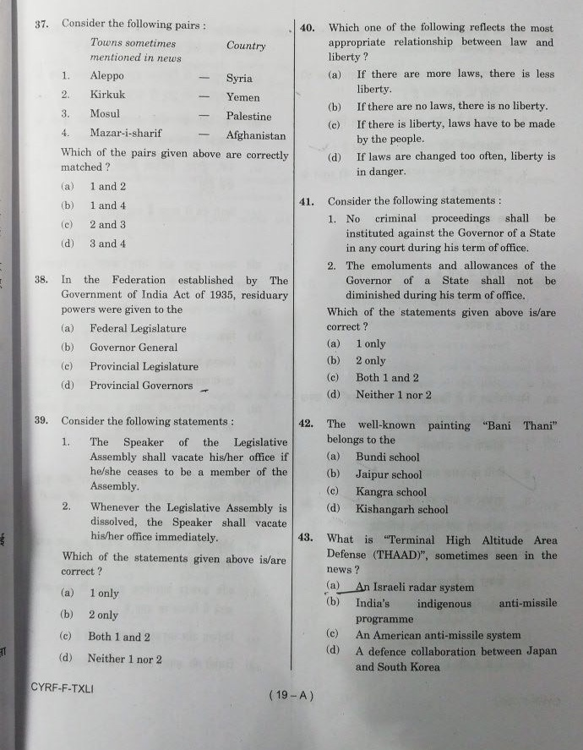](http://www.insightsonindia.com/wp-content/uploads/2018/06/IMG-5630.jpg)

[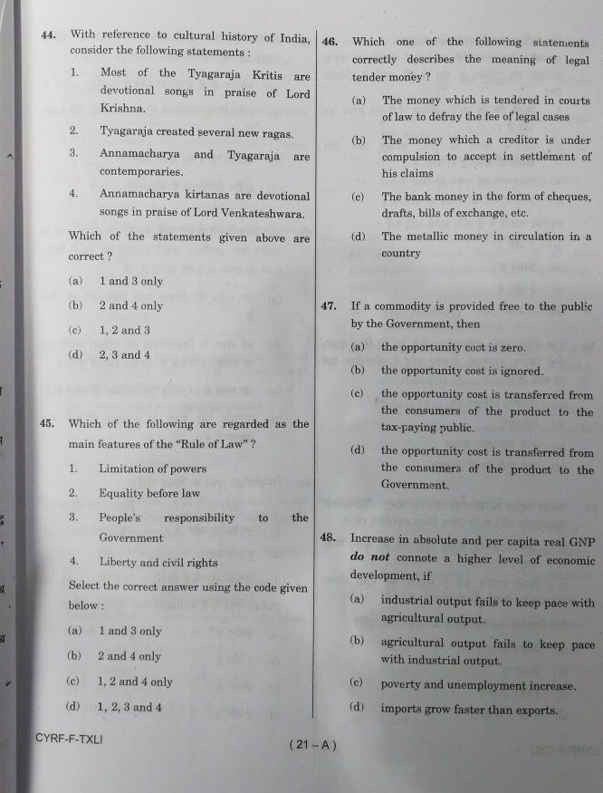](http://www.insightsonindia.com/wp-content/uploads/2018/06/IMG-5631.jpg)

[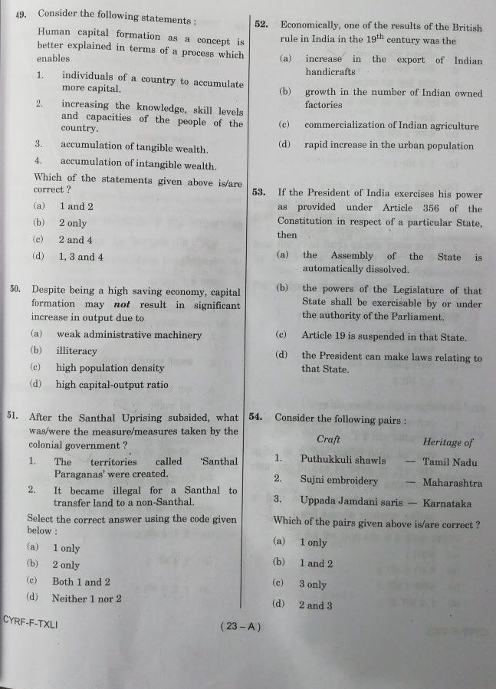](http://www.insightsonindia.com/wp-content/uploads/2018/06/IMG-5632.jpg)

[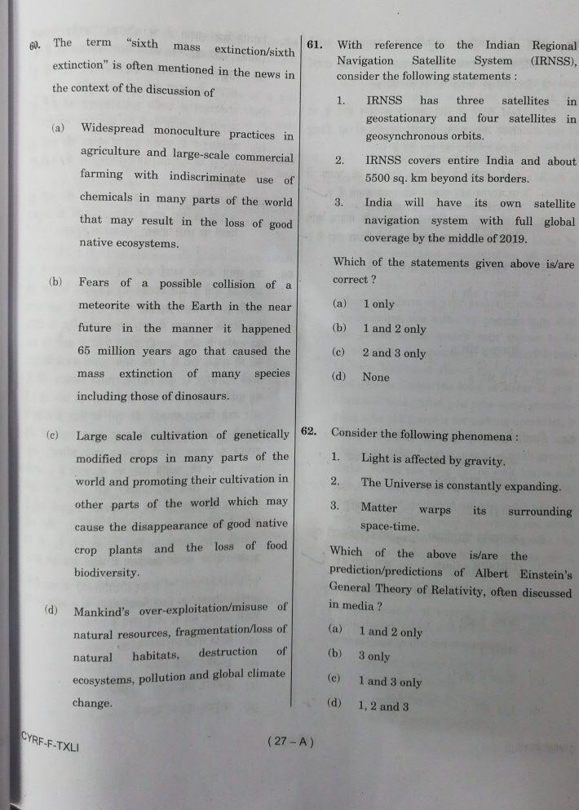](http://www.insightsonindia.com/wp-content/uploads/2018/06/IMG-5633.jpg)

[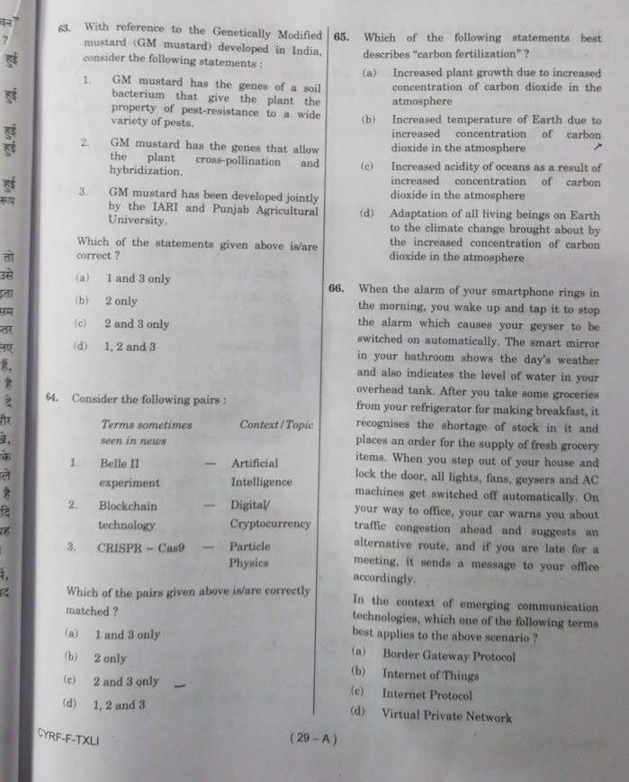](http://www.insightsonindia.com/wp-content/uploads/2018/06/IMG-5634.jpg)

[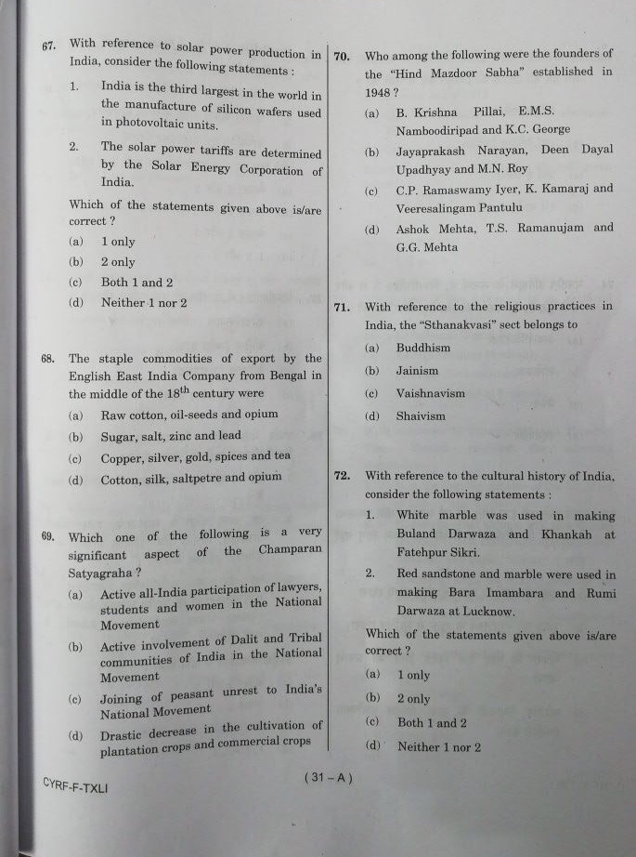](http://www.insightsonindia.com/wp-content/uploads/2018/06/IMG-5635.jpg)

[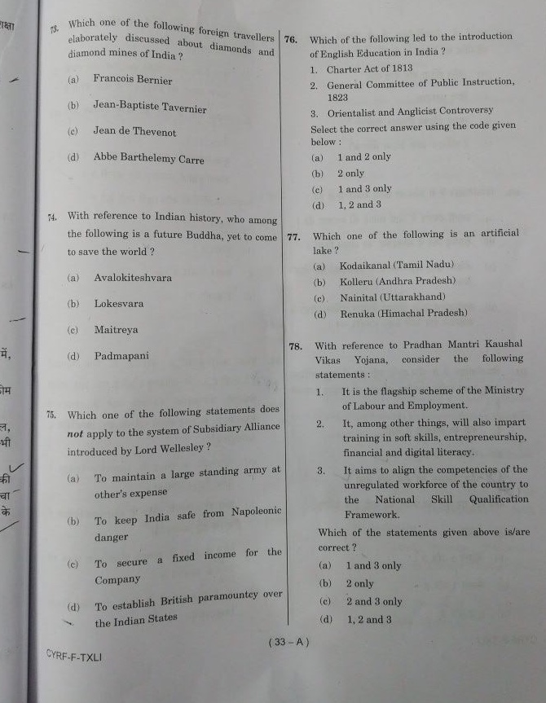](http://www.insightsonindia.com/wp-content/uploads/2018/06/IMG-5636.jpg)

[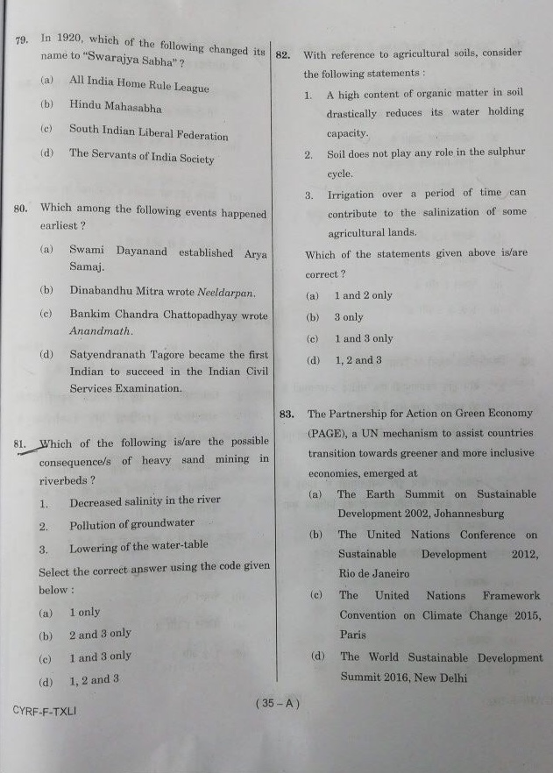](http://www.insightsonindia.com/wp-content/uploads/2018/06/IMG-5637.jpg)

[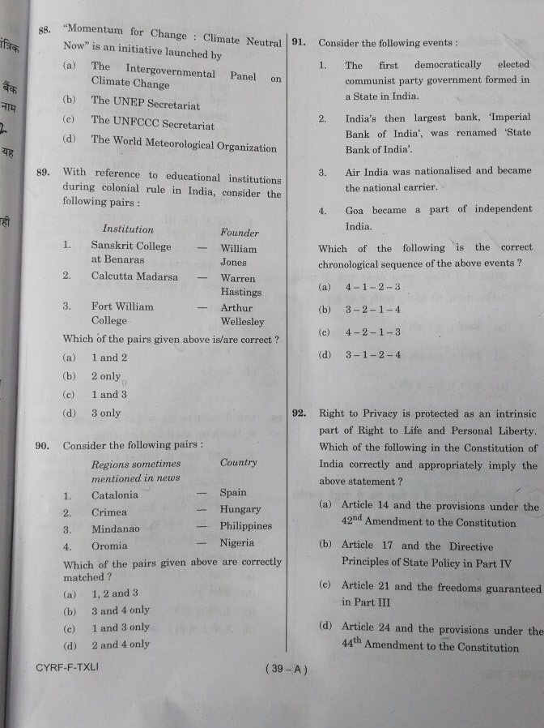](http://www.insightsonindia.com/wp-content/uploads/2018/06/IMG-5638.jpg)

[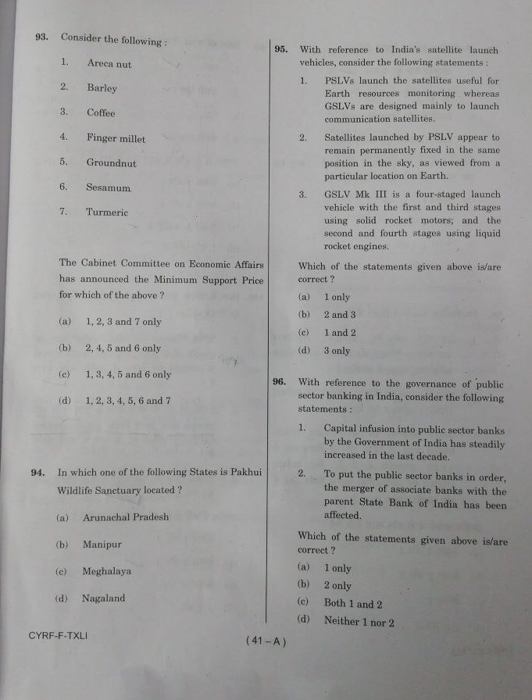](http://www.insightsonindia.com/wp-content/uploads/2018/06/IMG-5639.jpg)

[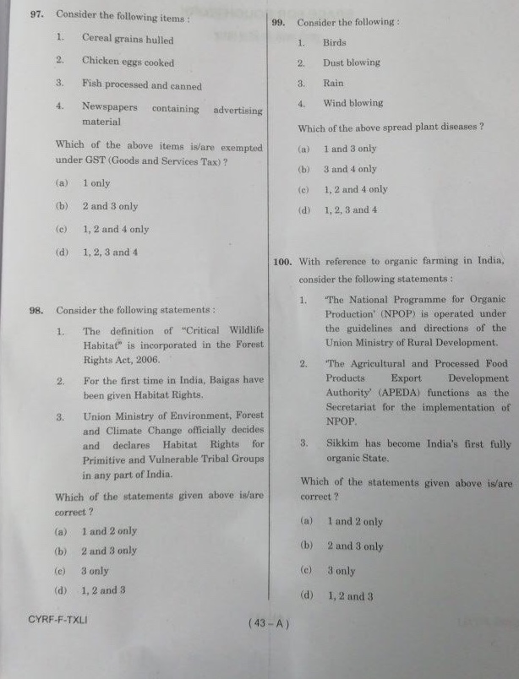](http://www.insightsonindia.com/wp-content/uploads/2018/06/IMG-5640.jpg)